Remote Access for Oracle XE

Some of you may want to connect to your Oracle XE database from a different machine. For example, your Oracle XE database is on your desktop machine, but you want to access it using SQL Developer on your laptop. This is possible, but if you are running any sort of firewall software on the machine with the Oracle XE database you will have to configure it to allow incoming TCP traffic on port 1521 (Oracle's default port). This includes Windows Firewall, which is activated by default in Windows Vista and Windows 7.

Note that you are opening a hole in your computer's firewall. Do this at your own risk.

Here are some screen shots of how to make the firewall configuration on Windows 7 Firewall. Your system may be different if you have a different version of Windows, or you have installed a third party firewall application (which is sometimes included with your anti-virus package).

**Step 1**

Start Windows Firewall.

[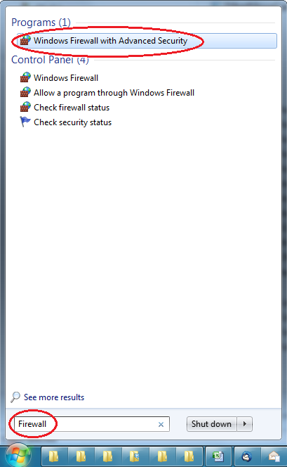](http://www.thatlink.com/Classes/cis2720sp14/images/OracleFireWallRule01.png)

**Step 2**

Click on "Inbound Rules", and then "New Rule".

[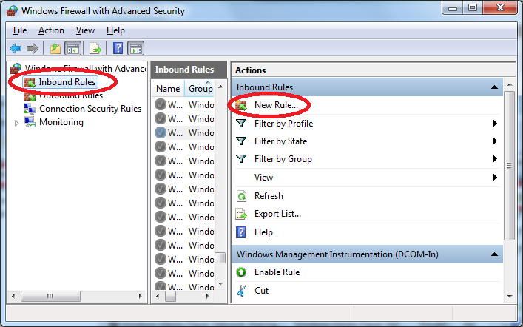](http://www.thatlink.com/Classes/cis2720sp14/images/OracleFireWallRule02.png)

**Step 3**

Click on "Port", as we will be opening up an inbound port.

[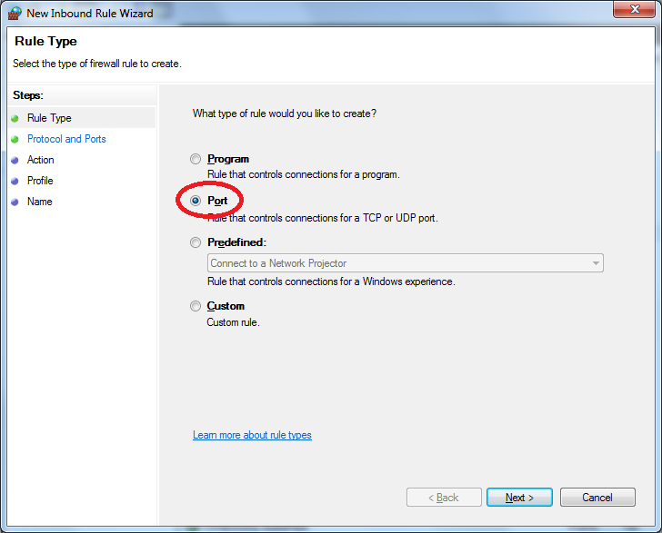](http://www.thatlink.com/Classes/cis2720sp14/images/OracleFireWallRule04.png)

**Step 4**

Click on "TCP", then "Specific local ports". Finally enter "1521" for the port number (Oracle's default port).

[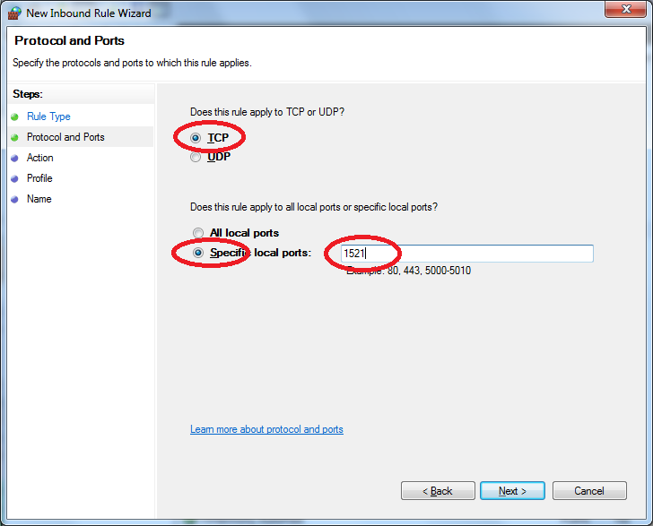](http://www.thatlink.com/Classes/cis2720sp14/images/OracleFireWallRule04.png)

**Step 5**

Click "Allow the connection".

[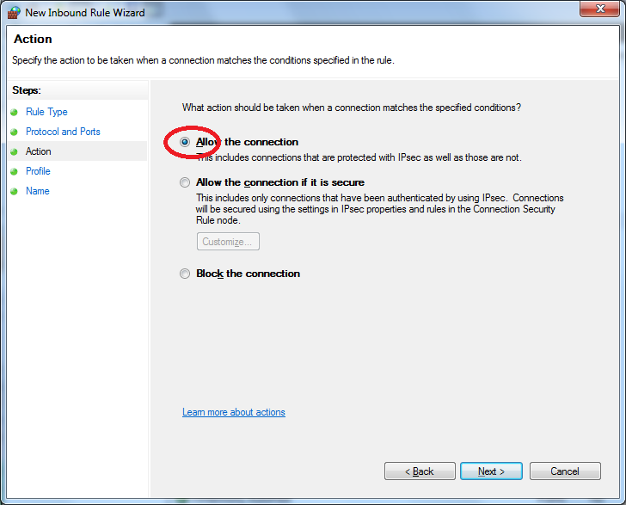](http://www.thatlink.com/Classes/cis2720sp14/images/OracleFireWallRule05.png)

**Step 6**

Now you have to specify which types of network connections to allow. This is up to you. I allow "domain" and "private", but not "public".

[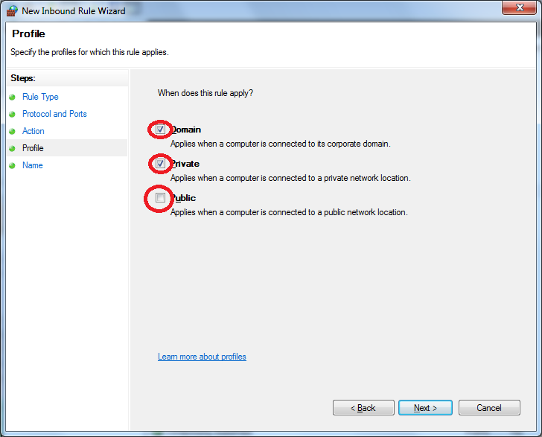](http://www.thatlink.com/Classes/cis2720sp14/images/OracleFireWallRule06.png)

**Step 7**

Finally, give your new rule a meaningful name. You can also add a comment in the description field.

[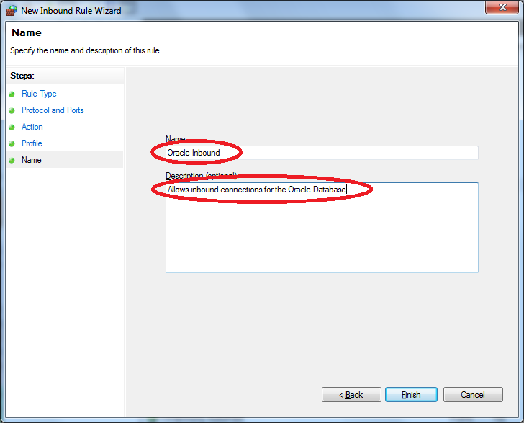](http://www.thatlink.com/Classes/cis2720sp14/images/OracleFireWallRule07.png)

**Step 9**

Now create a new connection in SQL Developer on your remote machine (i.e. not the machine with Oracle XE installed). Use all the same values you normally would, except for the "Hostname" field. Do not enter "localhost" or "127.0.0.1". Instead, enter the IP address of the machine that has Oracle XE installed. You can also use the machine name instead if you have your host file or DNS properly configured (although most home networks don't have this setup).

[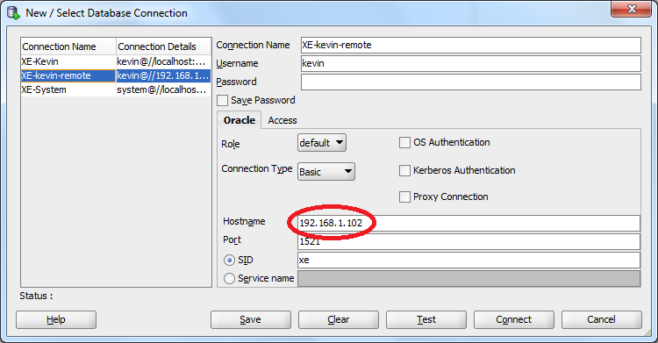](http://www.thatlink.com/Classes/cis2720sp14/images/OracleFireWallRule08.png)